**ACTIVITY 9:** **Intro to DBMS**

**Objectives:**

1. To know the difference between **SQL-DDL DROP and TRUNCATE**
2. To know more about SQL commands under DML such as **Insert, Update, Delete and Select.**

**Materials:**

PC or Laptop

WAMP/XAMPP Installer

Web Browser or CLI

**Background**

**Instructions:**

1. **Create java project “Pet Management System.” Then, drag all the files [Downloaded java file] including all classes to your project.**
2. **Click your Eclipse IDE Launcher.**

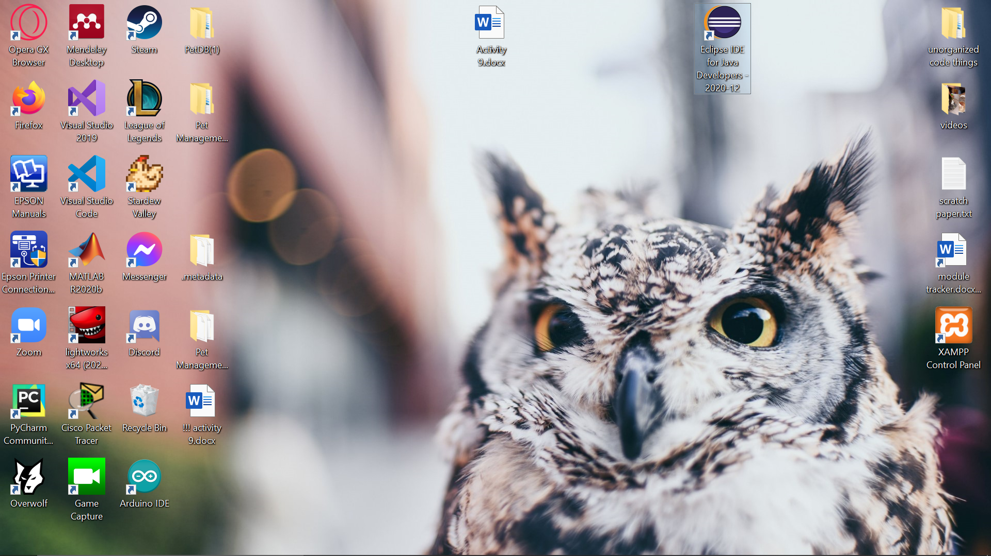

1. **Click the “Launch” button.**

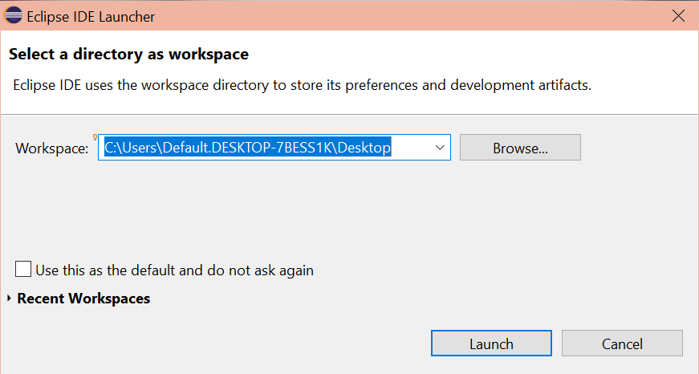

1. **Click “Create a new Java project.”**

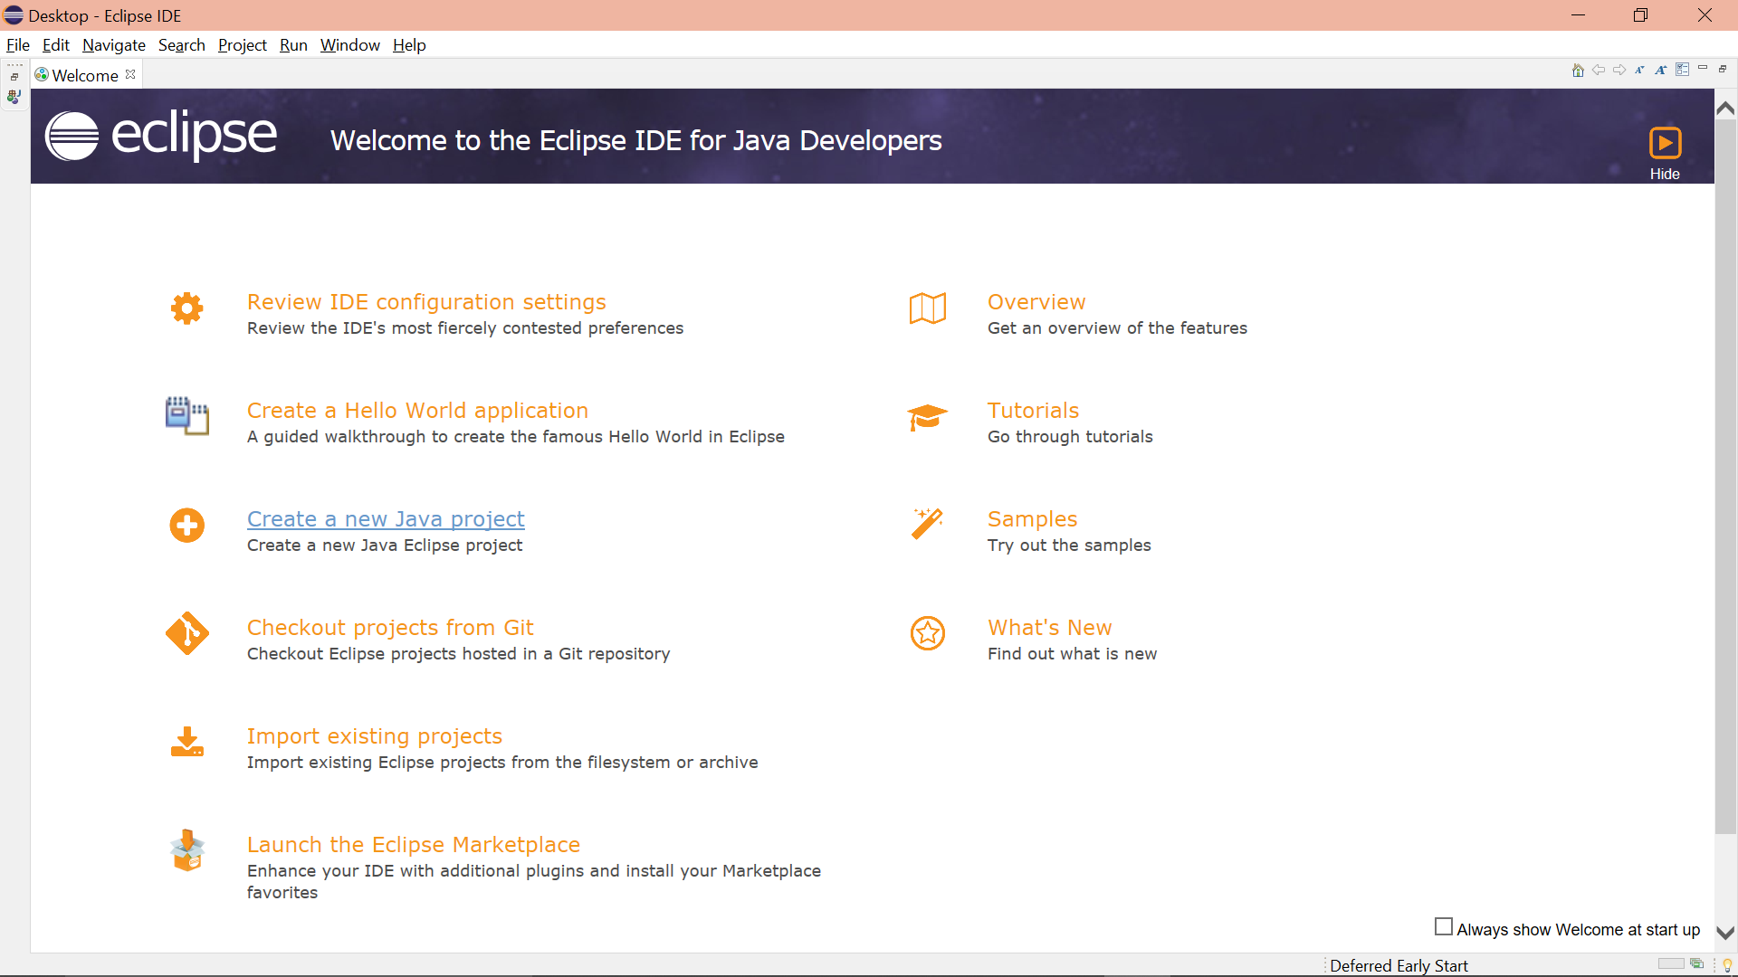

1. **Type in “Pet Management System” in the project name field. Click the “Finish” button.**

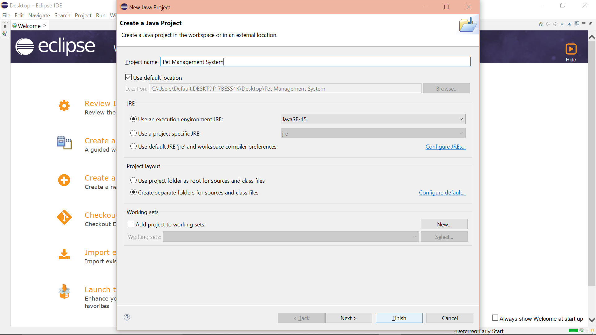

1. **Click the “Don’t Create” button in the window that pops up.**

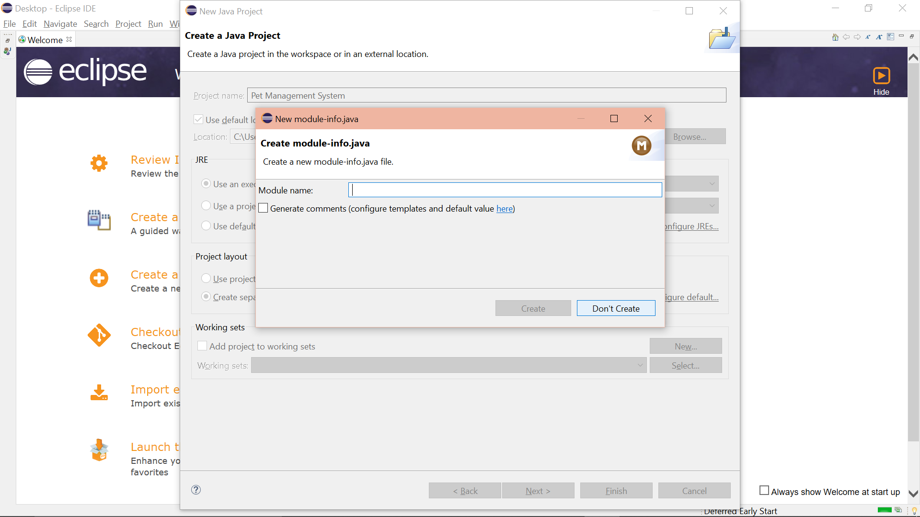

1. **I was unsure about which files are needed, so I just dragged all files from the provided database to my “Pet Management System” folder in the IDE.**

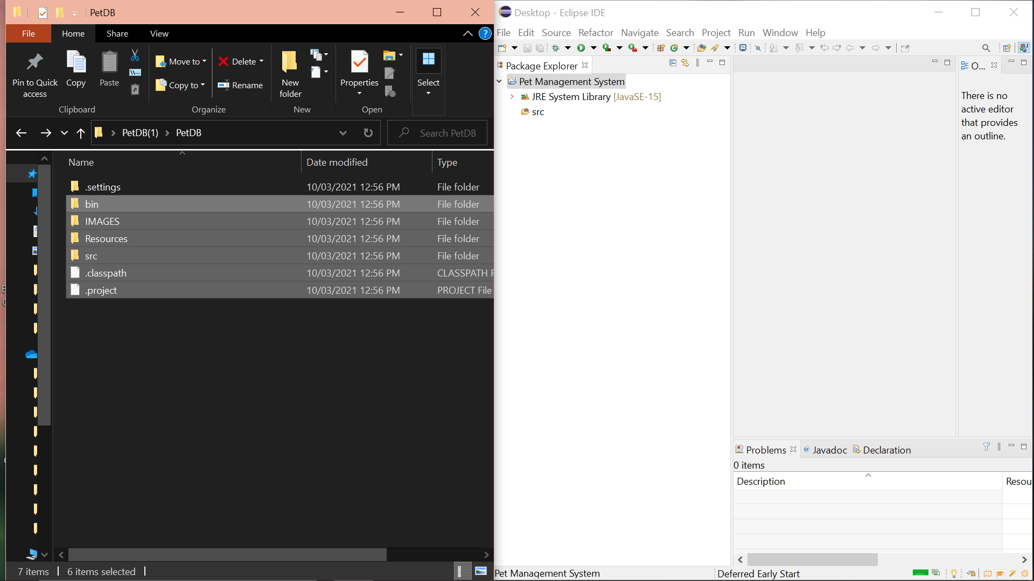

1. **Click the “Copy files and folders” option, then click the “OK” button in the window that pops up.**

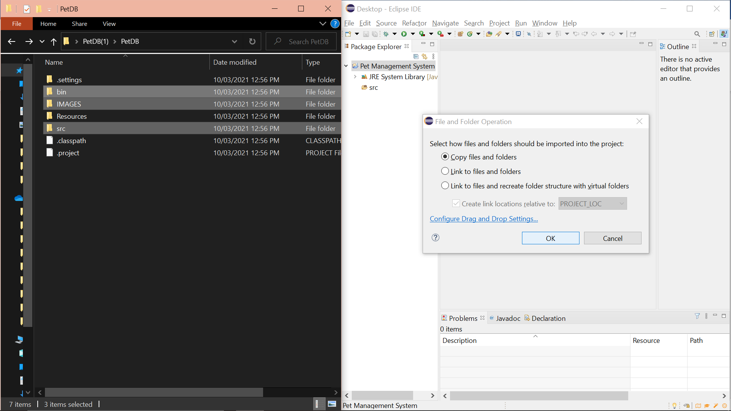

1. **Click the “Overwrite All” button in the window that pops up.**

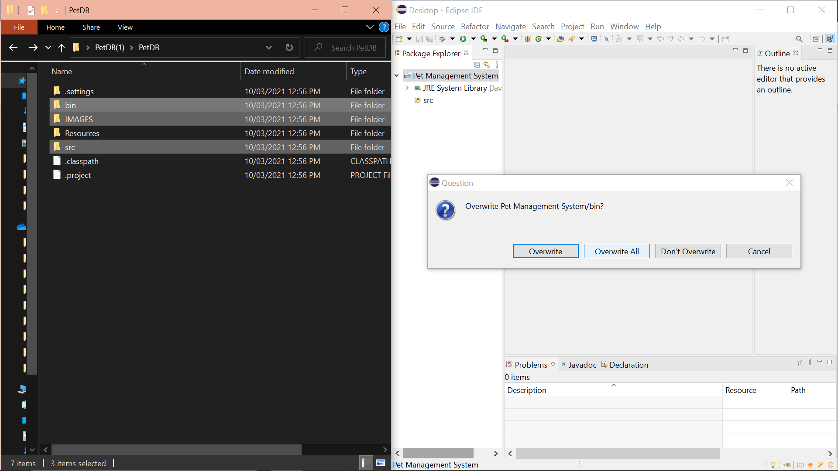

1. **Click the “OK” button in the window that pops up.**

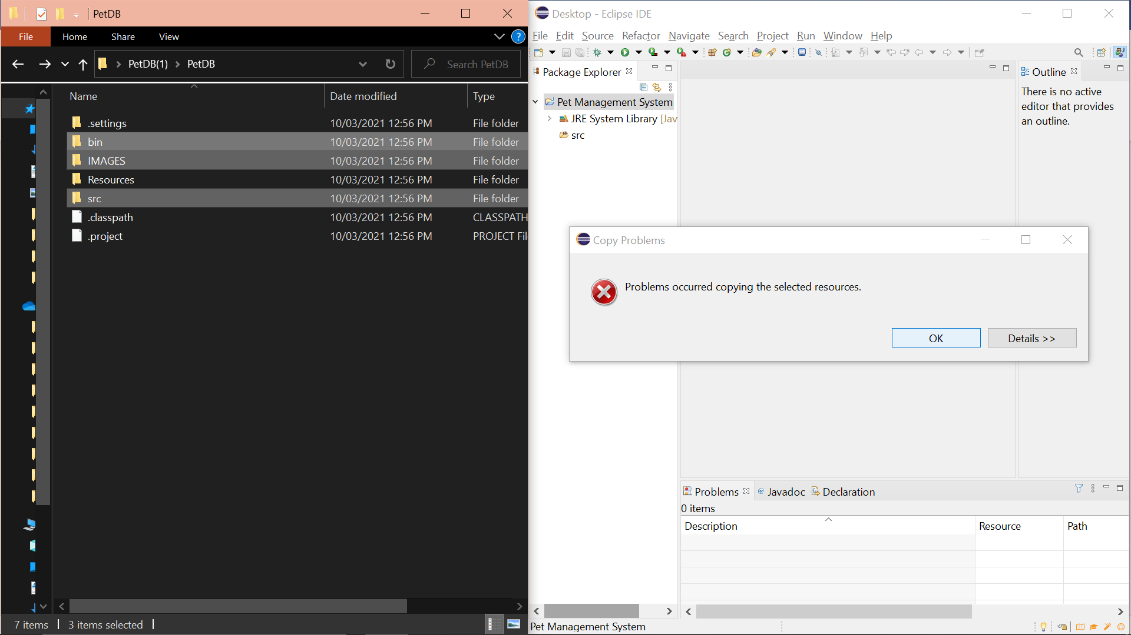

1. **This is how my IDE’s left panel looks like.**

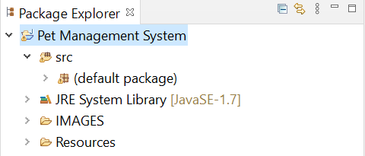

1. **Right click on the project. Then, click Build path>Add External Achieves**
2. **I clicked “Properties” instead to be able to do the following steps.**

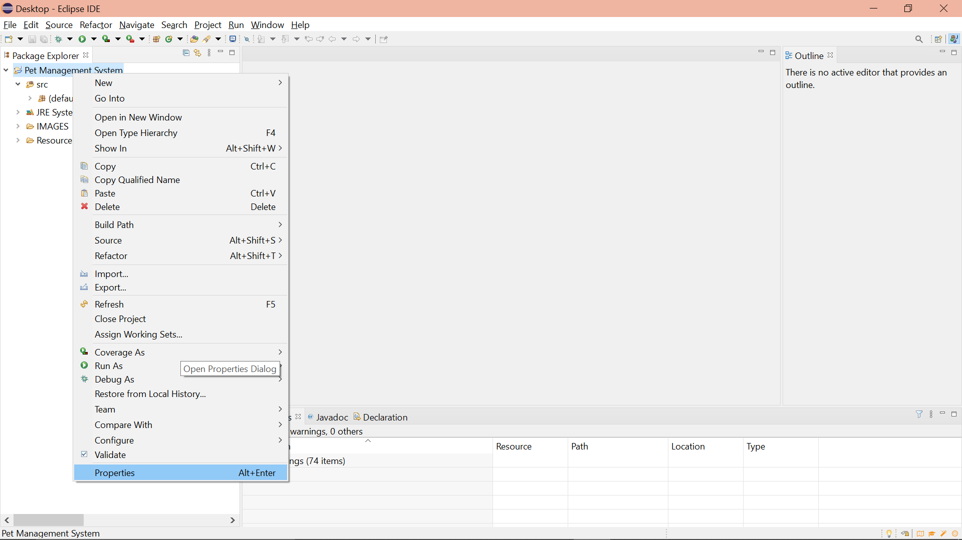

1. **Then follow the display below:**
2. **Click “Java Build Path” in the left panel.**
3. **Click the “Libraries” tab.**
4. **Click “Classpath.”**
5. **Click the “Add External JARS…” button in the right area of the window.**

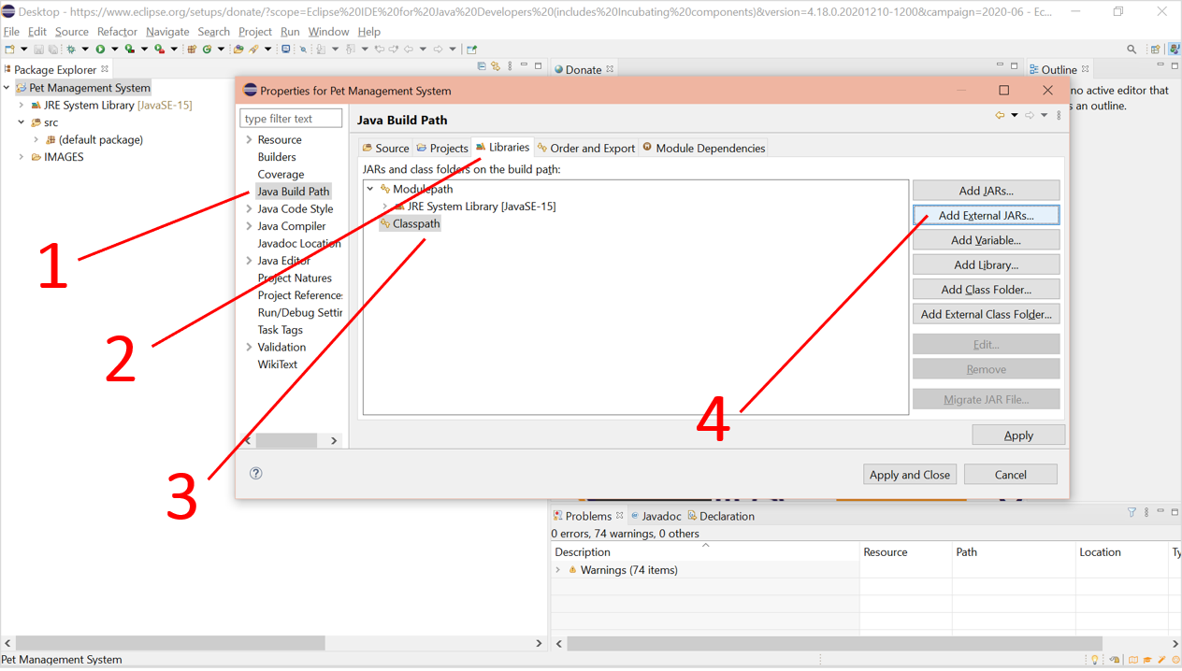

1. **Open all .jrar files.**

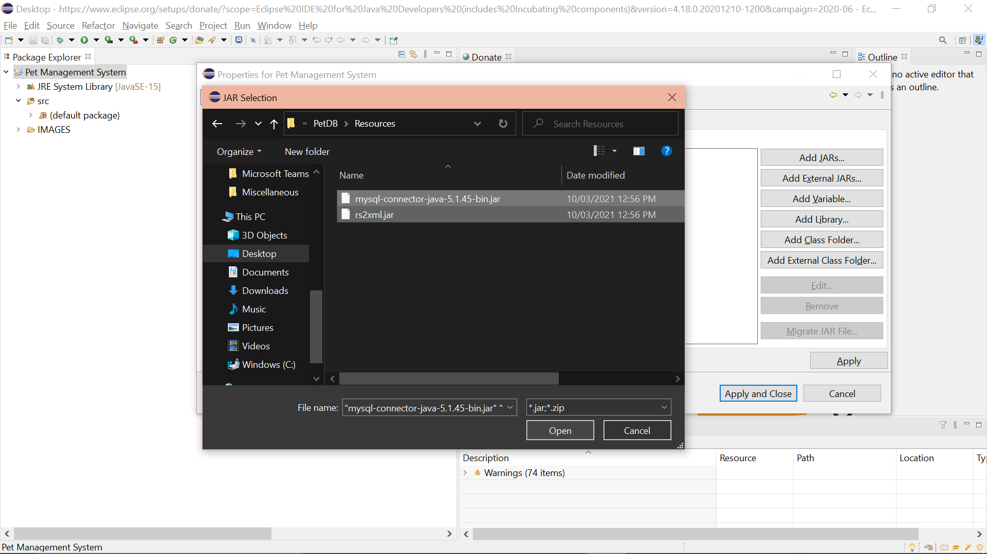

1. **Click the “Apply and Close” button.**

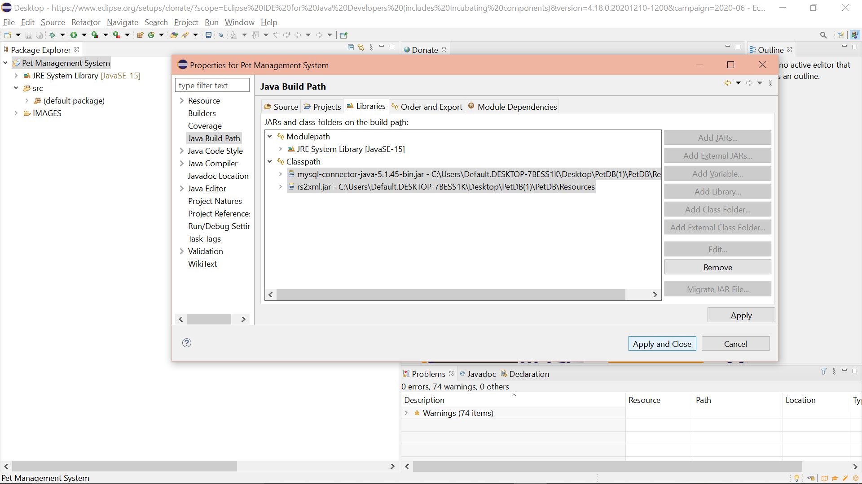

1. **Ensure that the .jar files are within the “Referenced Libraries.”**
2. **Click the “Database.java” file under *Pet Management System > src > (default package)***

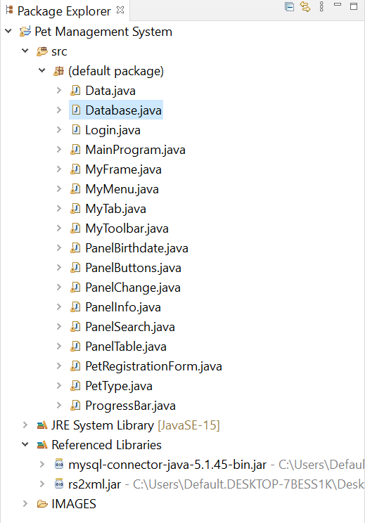

1. **Put in the provided code.**

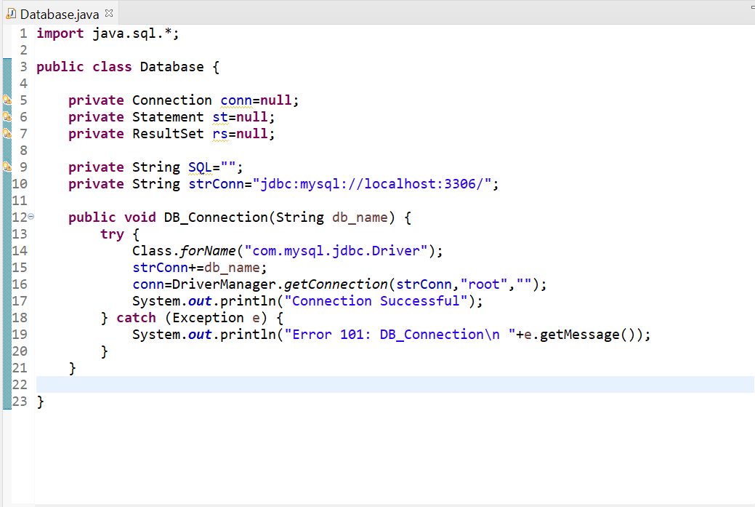

1. **Click the “MainProgram.java” file under *Pet Management System > src > (default package)***
2. **Put in the provided code.**

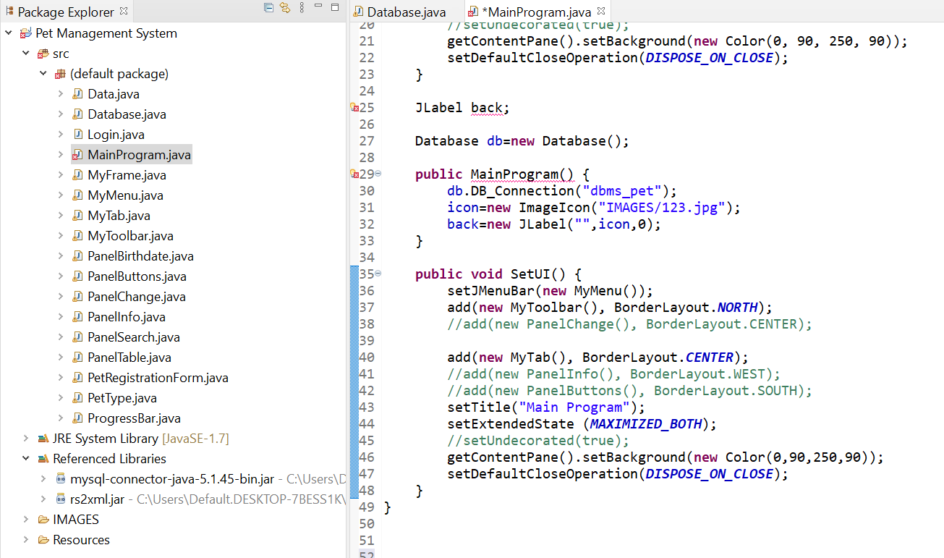

**Run the program.**

1. **Click the dropdown beside the “Run” button.**
2. **Click “Run Configurations.**

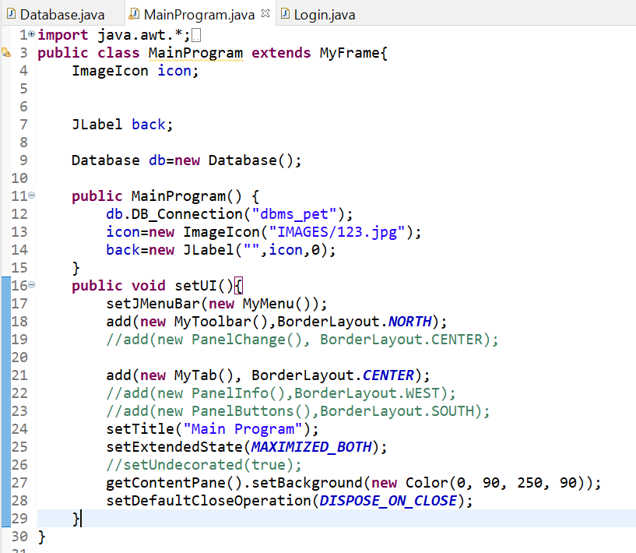

1. **Double click “Java Application” in the left panel.**
2. **Click “New_configuration.”**
3. **Click the “Search” button in the right side of the window.**

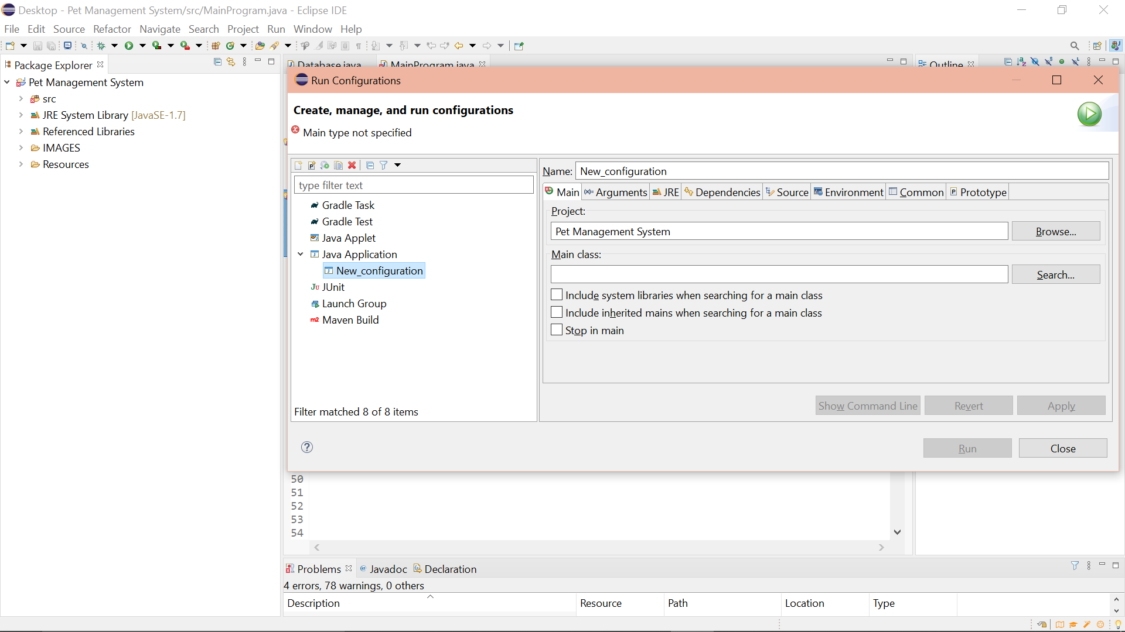

1. **Choose “Login – (default package).”**
2. **Click “OK.”**

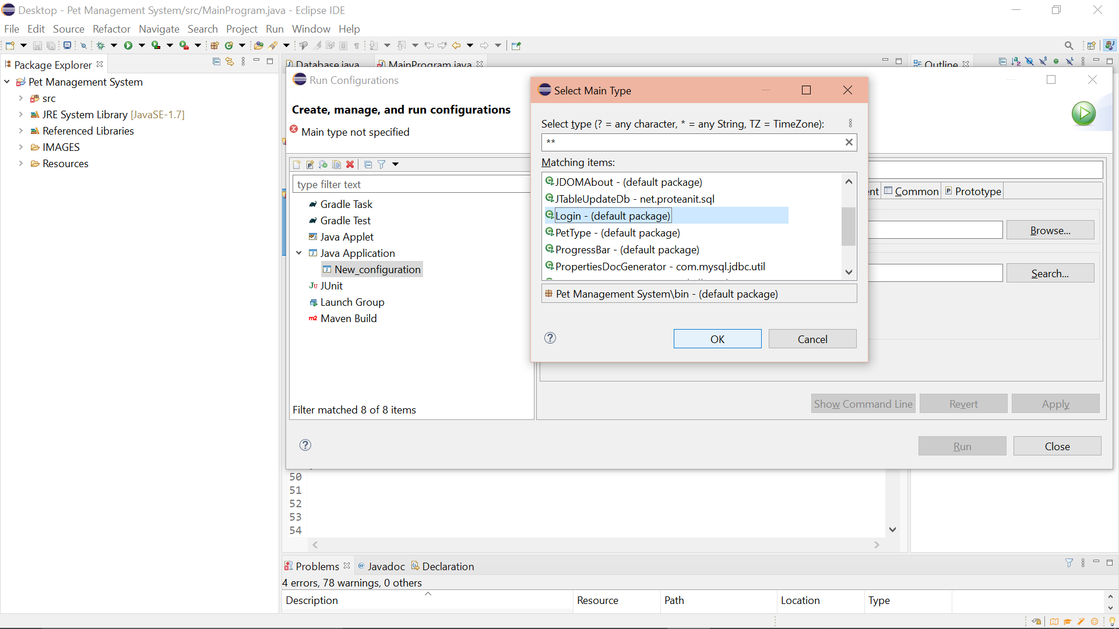

1. **Click the “Run” button.**

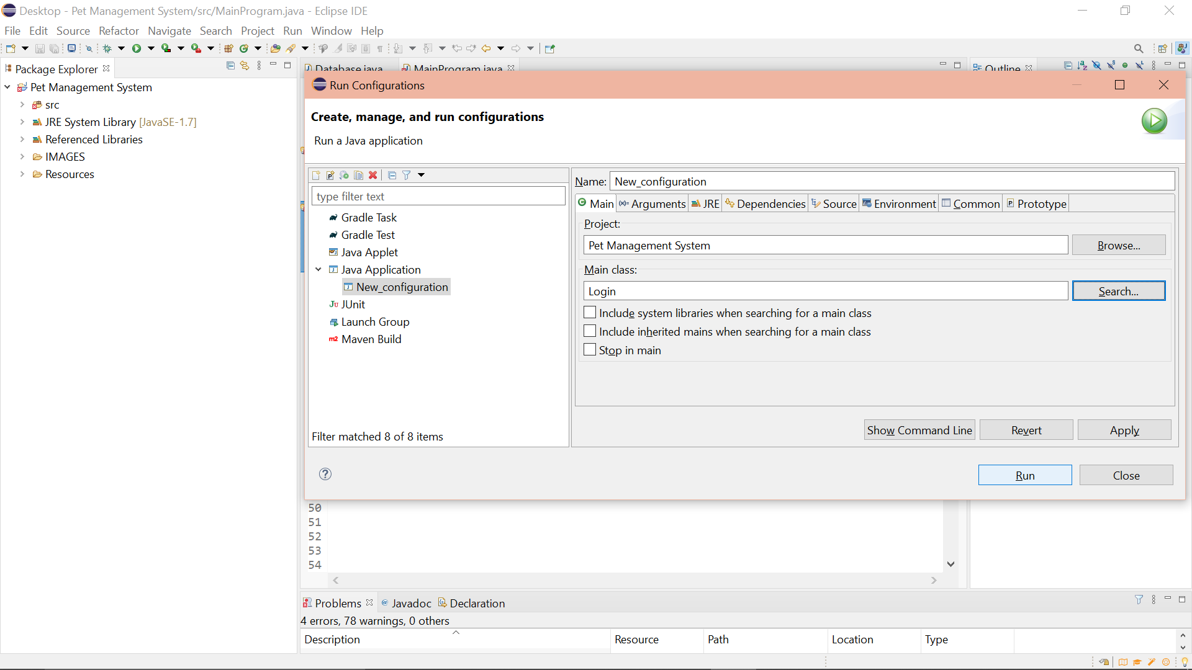

1. **I was redirected to the window below.**

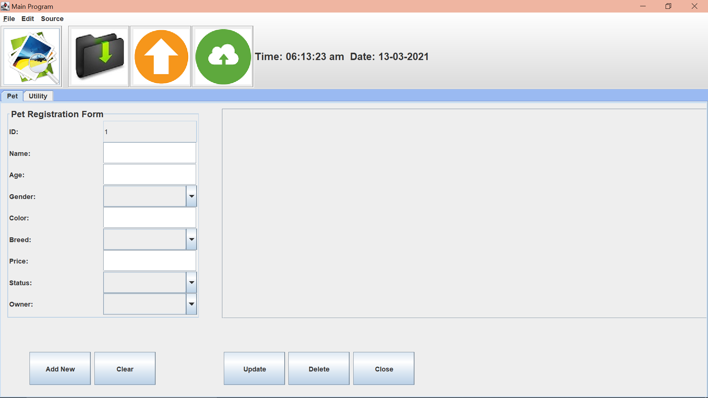

1. **The console showed the following error though:**

